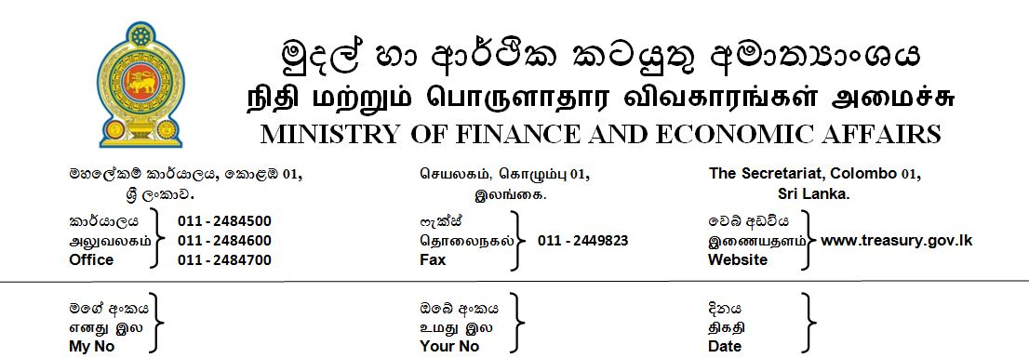

27.11.2018

Press Release
Finance Ministry rebuts social media reports on alleged illegal instruction to SL Customs
Attention of the Ministry of Finance and Economic Affairs is drawn to the reports in the social media on the alleged illegal instruction given by the Minister of Finance to the Sri Lanka Customs to release the foreign currency in US dollars that was apprehended while being illegally smuggled out at the BIA.

The Sri Lanka Customs officials sometime back had apprehended an outbound foreign national at the BIA while he was attempting to take out of the country, US D 53,455 in contravention of the Customs Ordinance. It was reported that the foreign nationals who work at the Uma Oya project, which is funded by the Republic of Iran, have sent their monthly salaries through this person out of the country.

The Iranian Ambassador in Colombo on October 03, made an appeal to the Minister of Finance to release this money on humanitarian ground saying that this money belongs to the employees working at Uma Oya project.

Accordingly, the Minister of Finance and Economic Affairs Mr. Mahinda Rajapaksa by virtue of the powers vested in him under section 164 of the S.L Customs Ordinance directed the Director General of Sri Lanka Customs to release this money to its legitimate owner.

This is not the first time that the foreign nationals who are working in the Uma Oya project taking their monthly salary out of the country. Previously when a foreign national was apprehended while attempting to smuggle out foreign currency, on a similar appeal the then Minister of Finance had directed the release of the money in June 2018 as well
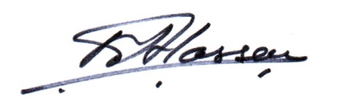
M.Ali Hassen
Director of Information
Ministry of Finance and Economic Affairs

