ITMIS - INTEGRATED TREASURY MANAGEMENT INFORMATION SYSTEM

Reforms in fiscal management facilitated by adoption of Information and Communication Technologies is among key modernization initiatives in many Government reform agendas as it offers many advantages to the management of public funds. Government of Sri Lanka is making significant strides in implementation of such reforms through Ministry of Finance (MoF) and has taken a series of coordinated steps for improving the fiscal management in the country, one of which is the ITMIS project.
ITMIS is envisioned to address the operational inefficiencies and overheads in the current environment through effective utilization of Information and Communication Technologies, where applicable. Implementation of ITMIS is aimed at simplifying the current business processes adopted by MoF and spending units for fiscal management, conversion of current business processes into self-services, to automate internal business processes and workflows surrounding Government financial management and to provide a comprehensive reporting and analysis framework to support MoF in effective planning and monitoring the Government finances.

ITMIS initiative is aimed towards establishment of a single and integrated information system to cater to the entire lifecycle of Government financial management. The key functions of the MoF and spending units that are proposed to be IT-enabled with the implementation of ITMIS include the following:

- Budget Planning/ Budget Appropriation  - Purchasing  - Commitment Management  - Imprest Release (Treasury fund release)  - Receipts Management  - Payment Management | - Debt Management  - Cash Management  - General Ledger  - Fiscal Reporting  - Internal Audit Management  - Cadre Information Management  - Asset Management

What are the benefits for you?

The key benefits of implementing ITMIS are:
- Providing the Government with a modern system, based on good practices, for fiscal operations management
- Improving planning, execution and control for Government budget and finances
- Improving access to information on financial and operational performance
- Improving the timeliness, accuracy and integrity of reporting on the fiscal performance of the Government
- Having an integrated system with seamless data transfer, prevent duplication of efforts, one time data entry and improve data quality
- Increasing internal control to prevent and detect potential financial leakages etc.
- Interfacing with other government agencies (Peoples Bank, Bank of Ceylon, Central Bank).

ITMIS Key Business Process Reengineering
- Implementation of Commitment Accounting
- Centralization of Payment in TOD
- Progressive move to accrual accounting
- Strengthening the link between planning and budgeting
- Implementation of Unified Chart of Accounting

Unified Chard of Accounts
HEAD
(3 digits)
PROGRAM
(2 digits)
PROJECT / SUB PROJECT
(4 digits)
OBJECT / ITEM
(4 digits)
FINANCING DETAILS
(2 digits)
FINANCING SOURCE
(2 digits)
ORGANIZATION
(7 digits)
PROGRAM / PROJECT
(9 digits)
OBJECT
(8 digits)
Contained
Converted
Contained
Contained
New CoA
Old CoA
FUND
(2 digits)

A unified chart of accounts links together the budget classification used to define revenues, expenditures and financing items used for budget planning, approval and execution with the accounting classification used to administer, record and report on financial transactions.

A unified CoA is the key prerequisite to operate an integrated financial management system such as ITMIS.

It facilitates;
    - Trouble free consolidation process.
    - Communication between entities.
    - Consistency in information

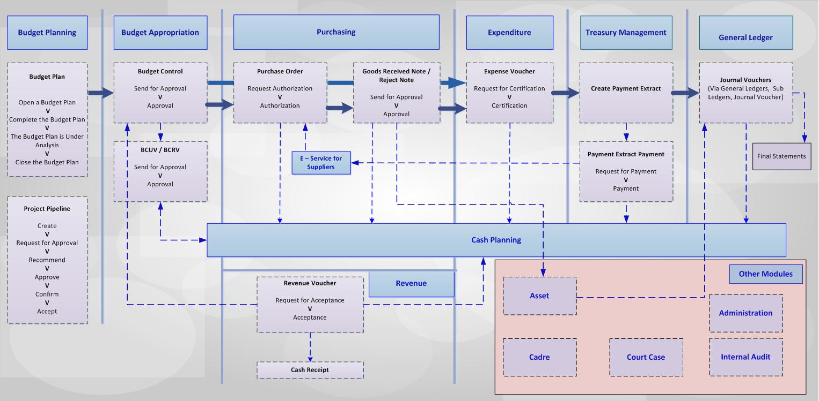
Linkage of ITMIS modules

Intrinsic Benefits of ITMIS
- Move to “less paper” dependant processes
  - E- forms to replace several printed forms - For example F.R. transfers.
  - E- register to replace paper registers - For example Fixed Asset Register.
  - Automated workflows to replace several letters.
    - For example approval/rejection of budget virements, submission of budget estimates, etc.
  - Less costly record keeping, improve timeliness
- Enhanced reporting capabilities
  - Central repository of data allows for on-demand financial reports
    - For example Trial Balance on demand
    - On-demand fiscal balance information
    - Central repository of government wide information like fixed assets and cadre.
  - Improves timeliness, accuracy and transparency of reports
Some of Automated Processes
- Government wide Fixed Asset Register
  - Central repository of all government assets
  - Information on assignments, location, end-of-life
- Automated cadre management
  - Central repository of all government cadre
  - Online request of changes to cadre
- Interfaces to other fiscal management computer systems
  - Banking (CBSL¹⁾, BoC²⁾, PB³⁾)
  - Debt Management (CSDRMS⁴⁾ and Domestic Debt)
  - CIGAS⁵⁾, Project Monitoring, GPS⁶⁾ and Pensions
Be ready with
- Study this document carefully
- Study FR 136 to 139
- Know that you are the right person for the training
  - Relevant person for the relevant module
- Get your access rights to ITMIS
  - Access to relevant functions
- Familiarity with a web browser (Chrome or Firefox)

වෙනසක් වෙමු ... වෙනස අත්දකිමු ...
Be the Change …. Experience the Change …

