2019.03.27
Press Release
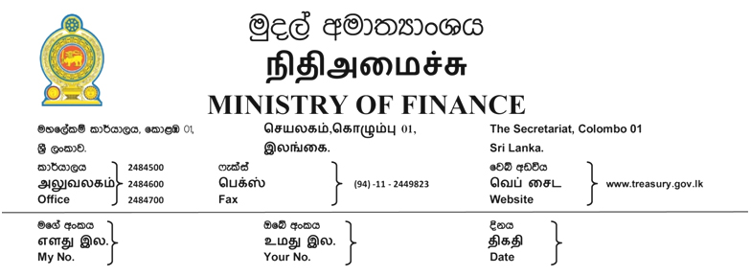
Germany to set up a Technical training Institute in Matara

The Government of Germany has agreed to provide Euro million Eleven as a grant to build a German Technical Training Centre in Matara to provide the State of Art training opportunities to youths in southern part of Sri Lanka. This centre will also be equipped with facilities for the training of trainers and instructors needed for other technical colleges in the country.

This project became a reality following the request made by Mr. Mangala Samaraweera when he was the Minister of Foreign Affairs in 2015. In 2016 another German training centre was set up Kilinochchi to provide the youths from north

The Ceylon-German Technical Training Institute (CGTTI) was the first organization set up with German assistance in Sri Lanka. It is the foremost institute in Sri Lanka for the training of skilled technicians in the field of Automobile Engineering and allied trades. This was a result of an agreement made in 1958 between the government of Federal Republic of Germany and Sri Lanka to supply training assistance.


M. Ali Hassen
Director of Information
Ministry of Finance

