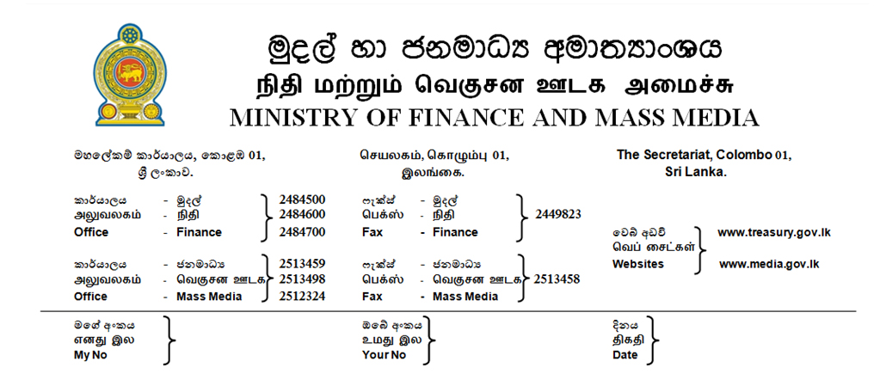
27.01.2019
Rs 2 M for 3-wheel owners and Rs 10 million housing loan for migrant workers under the expanded Enterprise Sri Lanka loan scheme –
- Ministry of Finance and Mass Media

The Government on realizing the success of Enterprise Sri Lanka concessionary loan scheme is to introduce further concessionary loan to widen the schemes enabling the stake holders to move towards next generation economic activities in their areas of activities. Accordingly migrant workers will be given up to Rs 10 million concessionary housing loans to be repaid in 15 years with two year grace period.
It has been perceived that the dream of many of the migrant workers is to have their own house. But due to lack of proper guidelines and financial management it has made it impossible for them. According to the new scheme proposed, those migrant workers who have registered under the Foreign Employment Bureau will have to save a considerable amount of their remittance in a local bank and the 75 % of the interest rate will be borne by the government through Treasury.
Another novel scheme introduced is to provide concessionary loan up to Two million rupees to three wheel owners to convert to a safer and comfortable mini taxi service with small cars. The government will bear 75 % of the interest rate and the three-wheel owners, who operate their own three wheelers and who are above 35 years of age are entitled to this concessionary loan
A proposal made by the Minister of Finance and Mass Media Mr. Mangala Samaraweera to expand the already approved loan schemes to cover more areas was approved by the Cabinet of Ministers last week.
The Enterprise Sri Lanka concessionary loan scheme introduced under Budget 2017 and 2018 has been a huge success. The self employed, Women entrepreneurs, small and medium entrepreneurs have so far been registered for various loan schemes up to Rs 65 billion via state and private banks and the loan worth Rs 36 billion have been disbursed to over 34,500 personnel. Self employed, farmers and even the journalists are given interest free from under this.
As Sri Lanka is fast reaching a country where its ageing population is on the increase the Minister of Finance Mangala Samaraweera has proposed to introduce another loan scheme of providing Rs 10 million with 75 % interest concession to construct elderly care centres as the private sector investment.
The newly introduced loan schemes with the previous schemes will be continued in the year 2019 as well and on the proposal made Mangla Samaraweera the Cabinet approval has been granted to allocate Rs 700 million to pay the interest rates to the Bank through which these loans will be channeled. The Treasury has been authorized by the Cabinet to enter into agreements with State and private banks to extend the loan scheme in this year too.
The Enterprise Sri Lanka programme inaugurated on June 22, 2018 previously consisted of 16 schemes and the special feature is that the government on behalf of the loan recipient pays either the total interest or part of the interest to the relevant Bank.
The Enterprise Sri Lanka scheme offers attractive concessionary financing to stimulate investment and expansion by entrepreneurs, SMEs and even large business. The loan amount ranges from Rs.50,000 to Rs.750 million.

M.Ali Hassen
Director of Information
Ministry of Finance and Mass Media

