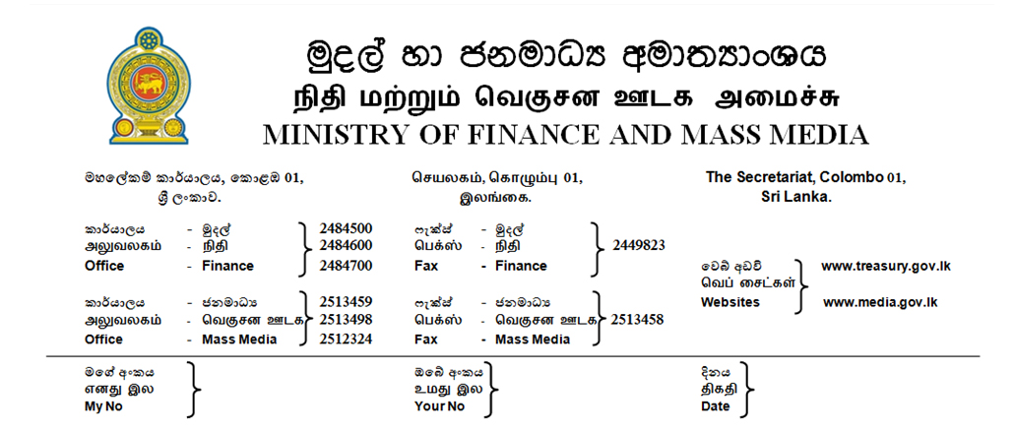

08.01.2019
11

PRESS RELEASE
Cabinet approves the Appropriation Bill – 2019, Annual expenditure will be Rs. 4,470 billion.

The approval of the Cabinet of Ministers was granted to the Appropriation Bill-2019, submitted by the Finance and Media Minister, Mangala Samaraweera. Accordingly, this year’s state expenditure will be Rs 4,470 and the budget deficit will be 4.8 % of the GDP.
The State revenue which was 11.5 % of the GDP in the year 2014 was gradually increased after the present government came in to power in 2015 and, it is expected to be increased to 15.% of the GDP this year.
This year’s National Budget is prepared under the Medium Term Fiscal Framework (MTFF) by adopting the performance based budgeting approach with the aim of strengthening the on-going fiscal consolidation programs. The government is also aiming to achieve the target of increasing the State revenue to 17 % and limiting the recurrent expenditure to 15 percent of the GDP in the year 2021.

Rs.2, 200 billion has been allocated for debt servicing in 2019. This is the highest; a government in the history of this country is compelled to bear for debt servicing. The recurrent expenditure include Rs 1,425 billion while the Capital expenditure will cost Rs 838 billion.

The Appropriation Bill will be presented in the Parliament on February 5th and the Budget proposal will be presented by the Minister of Finance and Mass Media Mr. Mangala Samaraweera on 5th March.
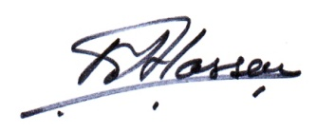
M.Ali Hassen
Director of Information
Ministry of Finance and Mass Media

